[Solar Powered Windmill Computer Controlled System]

Usability Test

**[RUBA ABID]**

**25th December, 2018**

**Table of Contents**

Contents

**Introduction 2**

**Methodology 4**

**Sessions 4**

**Participants 5**

**Evaluation Tasks/Scenarios 5**

**Results 5**

**Time on Task 7**

**Errors: 7**

**Conclusion 8**

## Introduction

This project revolves around the controlling of Windmill Solar Plants installed at the roadsides, through the computer systems. The basic aim of this project/app is to provide detailed information, time to time about the plant to it’s inaugurator. The inaugurator could avail this controlled system and in turn it could become quite beneficial for him as he could watch over the plant by just sitting at home.

* This web app could notify an installer about the traffic being gathered on the road which will resist the generation of wind, so that he could resolve the issue. This app will detect traffic on roads through sensors installed in the roads.
* This computer control app will calculate the continuous solar energy production at the speed of wind measured in anemometer.
* The main objective is to notify the user about the Mill Failure function.
* This app will come along with the preinstalled weather forecasting software which will predict the weather.
* Automobile speed detection feature will be available in the app to assist the user to make conclusions out of it easily.

The aforementioned objectives of this control system will be providing facilitation to it’s users/installers/inaugurators of the solar plant to have a 24/7 check-on over their installed plants.

This usability test on the project SPWCCS was conducted to actually get to know about how really people would interact with it. Either they feel comfortable using the functionalities the developers used. It was initially conducted by the developers end through which they analyzed that participants are more focused on instructive flow on the sites. They seek a smooth flow of their choices within website boundary and will get attracted to buttons and navigational flows with pictures. Thus, we being the developers and designers asked them to get through the site and gained their feedbacks as the results. Each participant had different mindset for which they reviewed differently. At the end of the session, it was finally concluded that every easiest and simplest feature in the site was more appreciated by the users. So, keep it SIMPLE!

**Executive Summary**

The SPWCCS project team conducted an onsite usability test at Library Park, Bahria University Karachi Campus on Dec 20th and Dec 21st, 2018. The purpose of the test was to assess the usability of the web interface design, information flow and information architecture.

3 of the University students participated in Test 1 however 2 of them participated in Test 2. Typically, a total of 5 participants were involved in a usability test to ensure stable results. Each individual session lasted approximately 15 to 20 minutes. Test scenarios differed over the two Test days to meet usability criteria.

In general, all participants found the SPWCCS website to be clear, consistent and straightforward. 80% of them were comfortable with the simple architecture of the site and remaining were satisfied with the flow of the system. Since, the aim of this site is to provide control over the windmills therefore controlling system through cctv and sensors is not a huge problem.

The test identified only a few minor problems including:

* + **The Login page differ for Employees could have separate button.**
  + **Confusion over apparent editing in the Control Room data.**
  + **Lack of descriptive sheets for new users.**
  + **Lack of a site index.**
  + **Lack of any categorization of news items on the news page.**

This document contains the participant feedback, satisfactions ratings, task completion rates, ease or difficulty of completion ratings, time on task, errors, and recommendations for improvements. A copy of the scenarios and questionnaires are included in the Attachments’ section.

## Methodology

### Sessions

Each Participants was recruited through the special announcement made in class before the session in which audience was addressed as “Who so ever is interested to evaluate our prototypes could gather in Library park, as that’d be a great honor to have you as our testers”.

Each participant then was asked to do individual tasks.

Every session took approximately seconds. Participants showed the confusing behavior at the beginning but then were settled soon as they understood the flow.

Every individual was asked to first read the manual and the abstract so that it may assist them for future need. Though the architecture was simple but still it seems to be a bit difficult for the new users.

Thus, it was concluded that employees and administrator using the system for the first time could take help from the manual since it’s always tricky for first time users. We took the feedback from every individual and in return they get with the simple yet easy architecture.

### Participants [5 Participants] (The names will not be mentioned)

Participant 1, 2 and 3 were present on the TEST day 1 and remaining were gathered on TEST day 2.

Time length in total was 1-2 minutes for each test day.

### Evaluation Tasks/Scenarios [6 Scenarios]

The task scenarios were conducted by the project team Ruba and Hafsah which included the following scenarios:

**1. To view the video surveillance of the mills through the specific tab on the navbar**

**2. To view the notifications from administrator end being the employee.**

**3. To view the manuals being an administrator of the click on the link.**

**4. To log onto the employee platform.**

**5. Update, delete and insert the employee data from employee’s list from admin’s end.**

**6. To view the notifications of the mill failure function through the administrator’s end.**

## 

## Results

Calculate each of the following with 5 Participants and the number of scenarios attempted:

* ***OVERALL USER EFFECTIVENESS:***

Formula:

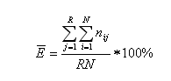

There are total 5 users and 6 scenarios. All 5 users successfully completed scenarios 1, 2, 3. First users successfully completed scenario 4 and last 4 user failed to complete. First 3 users successfully completed scenario 5 and last 2 user failed to complete. First 3 users failed to complete scenario 6 and last 2 users successfully completed scenario 6.

E= [((5*3) + (1*1) + (4*0) + (3*1) + (2*0) + (3*0) + (2*1) / 5*5] *100

E= .84 * 100

E= 84%

* ***OVERALL RELATIVE EFFICIENCY:***

Formula:

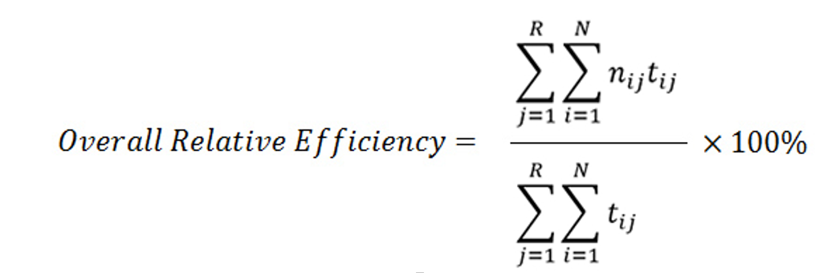

There are total 5 users and 6 scenarios. All 5 users successfully completed scenarios 1, 2, 3 in 5 seconds. First users successfully completed scenario 4 in 2 seconds and last 4 user failed to complete and took 10 seconds. First 3 users successfully completed scenario 5 in 3 seconds and last 2 user failed to complete and took 6 seconds. First 3 users failed to complete scenario 6 and took 8 seconds and last 2 users successfully completed scenario 6 in 4 seconds.

E= [(5*5) + (1*2) + (0*4) + (3*3) + (0*6) + (0*) + (2*1)] / (25+2+10+9+12+24+8)* 100

E= 44/90*100

E= 48.8 s

* ***SUS- SYSTEM USABILITY SCALE:***

|  |  |  |  |
| --- | --- | --- | --- |
| **S.no** | **SCALE POSITION** | **CALCULATION** | **SCORE CONTRIBUTION** |
| 1. | 5 | 5-1 | 4 |
| 2. | 1 | 5-1 | 4 |
| 3. | 5 | 5-1 | 4 |
| 4. | 2 | 5-2 | 3 |
| 5. | 4 | 4-1 | 3 |
| 6. | 1 | 5-1 | 4 |
| 7. | 5 | 5-1 | 4 |
| 8. | 1 | 5-1 | 4 |
| 9. | 4 | 4-1 | 3 |
| 10. | 2 | 5-2 | 3 |
|  |  |  | Total= 36  *2.5 = 90 |

* ***SUCCESS RATE:***

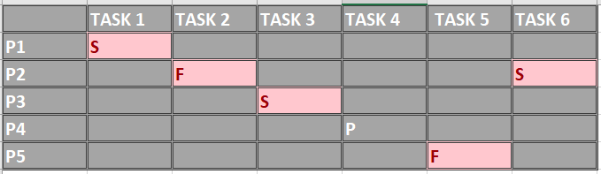

### The success rate can be calculated as:

Success Rate=[(S+(Tu*0.5))/Tp]x100

### Success Rate = [(3+(5*0.5))/6]x100

Success Rate = 91.6 %

### Time on Task

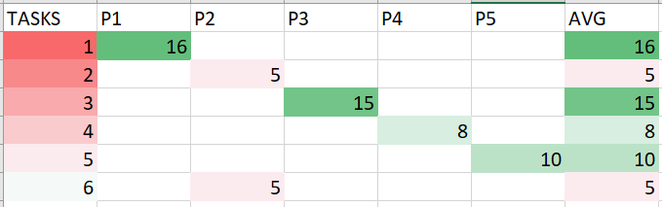

### 

### Errors:

**Participant 3: Made an error in Task 3.**

Task 3: The participant was not able to view the manuals being an administrator of the click on the link because the internet connection was not available.

**Participant 2: Made an error in Task 2 and Task 6.**

Task 2: The participant was not able to view the notifications from administrator end being the employee. He couldn’t receive important notifications from Admin.

Task 6: Same goes with this task because the Admin cannot view notifications of the mill failure function since the sensor has been failed to detect.

#### Likes, Dislikes, Participant Recommendations

**Liked Most**

* The participant most liked the cctv camera feature viewing windmills from every angle.

**Liked Least**

* The least liked feature was Weather Forecasting Software and Notifications panel which reveals chat bot.

**Recommendations for Improvement**

* Improvement shall include the usage of bootstrap functionalities to enhance the theme of the system, this current theme represents a childish background. And CCTV camera should be of high resolution. So that a user or administrator should view the surveillance more clearly to examine the errors and failures in the mill easily.

## Conclusion

Most of the participants found SPWCCS to be well-organized, comprehensive, clean and uncluttered, very useful, and easy to use. Having a centralized site to find reports and information is key to many if not all of the participants. Implementing the recommendations and continuing to work with users (i.e., real lay persons) will ensure a continued user-centered website.

Control over the system just by sitting at home is a key feature to many problems solved easily!